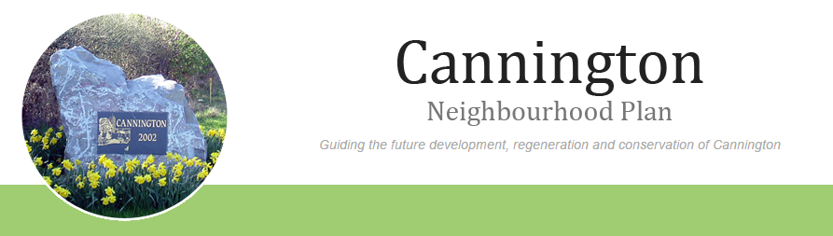

AGENDA

For a Neighbourhood Plan Meeting to be held on Monday 5th January 2015, 7.30pm to 9.00pm
in the Community Room, Cannington Village Hall.

- Welcome.
- Apologies for absence.
- Approval of the draft minutes of the meeting held on 15th December 2014.
- Matters arising (not on agenda).

- Budget Update and report to Community Development Foundation

- Website and online surveys update.
- Consultation leaflet
- Any other business.
- Dates of next meetings-
Monday 19th January 2015
Monday 2nd February 2015

