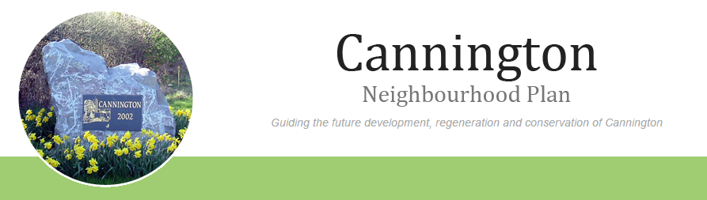

AGENDA

For a Neighbourhood Plan Meeting to be held on
Monday 2nd February 2015 7.00pm to 8.30pm
in the Community Room, Cannington Village Hall.

- Welcome including Jo Widdecombe of Planning Aid, Planning Consultant Mandy Goddard, Wendy Stother as minute taker.
- Administrative support
- Apologies for absence.
- Approval of the draft minutes of the meetings held on 5th and 19th January 2015.
- Matters arising (not on agenda).

- Resignation of Alex Reed and the need to co-opt additional member of the Group.

- Review of the joint meeting with the Parish Council on 19th January 2015.

- Aims and Objectives.

- Analysis of Consultation data.

- Review of Work Schedule.

- Budget Update and report to Community Development Foundation.

- Website competitions
- Any other business.
- Dates of next meetings-
Monday 16th February 2015
Monday 2nd March 2015

