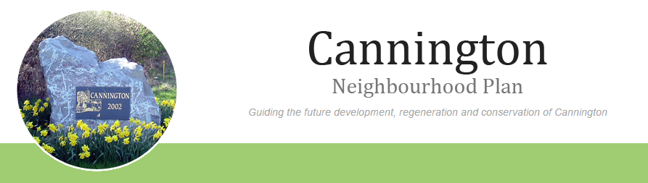

AGENDA

For The Neighbourhood Plan Steering Group Meeting to be held on
Monday 13th April 2015
7 30pm-9 00pm in the Community Room, Cannington Village Hall.

- Welcome.
- Apologies for absence.
- Approval of the draft minutes of the meeting held on 16th March 2015.
- Matters arising (not on agenda).
- Analysis of Consultation data.
- Review of Work Schedule.
- Website
- Budget.
- Any other business.
- Suggested dates of next meetings-
Monday 27th April 2015
Monday 11th May 2015

