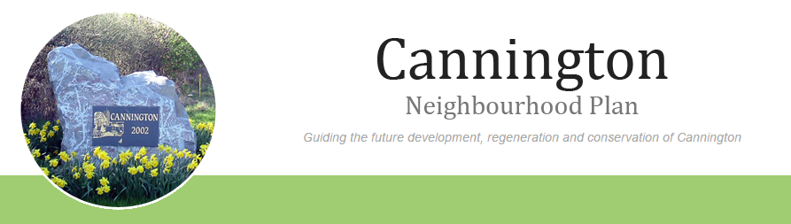

Welcome to the Business Survey.

Thank you for participating in our survey. Your feedback is important.

We will not pass on any information to other bodies. This is simply an information collection scheme for the benefit of our village and those that use the facilities.

1. Name of Business

2. Trading Address

3. Contact person

4. Position in company

5. E-Mail address (as validation, will not be given to other parties)

6. Contact Telephone Number (this is optional)

7. How would you categorise your business?
Accommodation and Food Services
Agriculture, Farming, Forestry, Fishing
Animal Care and Welfare
Arts, Entertainment & Recreation
Business Administrative and Support Services
Construction
Distribution & Warehousing
Education
Electricity, Gas, Steam or Air Conditioning Maintenance/Repair
Financial and Insurance
Hairdressing
Health & Beauty
Horticulture/Nursery
Human Health and Social Work Activities
Information and Communication
Manufacturing
Mining, quarrying
Motor Trades & Services
Professional, Scientific and Technical
Property Sales & Trading
Property Maintenance
Retail
Tourism
Wholesale
Other (please specify)

8. Do you sell to or provide services directly to other companies? If so what proportion (%) would you estimate?
Mainly within the village vicinity.
Within the village and surrounding districts
Nationally
International

9. Do you sell/provide services to the public?
Via retail premises
Direct to customer's premises
Via the Internet

10. How old is your business?
0-2 years
3-5 years
6-10 years
More than 10 years

11. How many employees do you have?
Self employed
1-10
11-24
25-49
50-100
100+

12. Following on from Question above, how many of your employees are? .........
Contracted 37 hours and above
Contracted between 36 and 17hrs
Contracted 16 hours or below
Casual/Zero Hours (as required)
Seasonal
N/A Self Employed

13. What percentage of your employees live in the village?
0-25%
25-49%
50-75%
75-100%

14. What is the approximate size of your current workspace?
Work from home
Under 93 sq. m (1,000 sq. ft)
94-465 sq. m (1,000 - 5,000 sq. ft)
466-929 sq.m (5,001-10,000 sq.ft )
930-1,858 sq.m (10,001- 20,000 sq.ft)

15. Over the next 3 years do you think your workspace will continue to suit your needs?
Our current premises are likely to remain suitable
Our current premises are likely to become less suitable
We are already taking steps to improve or extend our premises
We will be taking steps to move to more suitable premises in/around Cannington
We will be taking steps to move to more suitable premises outside of Cannington

16. Do you think the current local transport network affects your business? 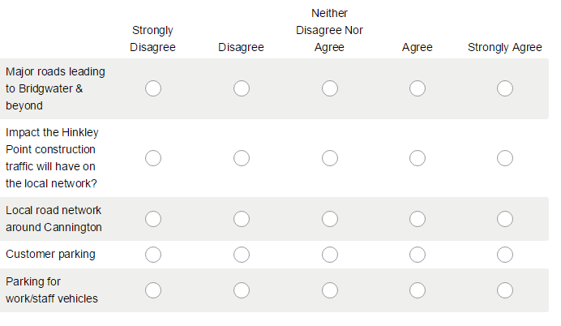

17. Which of the following services do you currently get from Cannington?
Legal
Communications
Web Development or I.T.
Creative design or Publishing
Management/Business Consultantcy
Hospitality
Local Shops/Post Office
Building Trades or Maintenance

18. Which of the following would most benefit local businesses?
Better public transport service for employees
Better road network
Buy local campaign
Futher improvements to broadband
Local business club
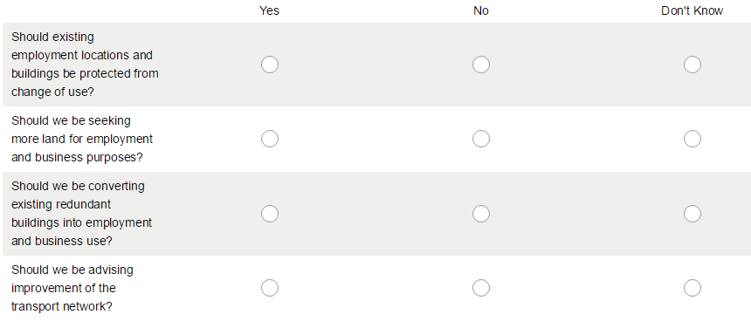
More parking

19. About Neighbourhood Planning and policies:

20. What do you see as the current benefits (if any) of having your business located in Cannington?

21. Do you have any general comments please add them here.....

