Cannington Neighbourhood Plan

***Guiding the future development, regeneration and conservation of Cannington.***

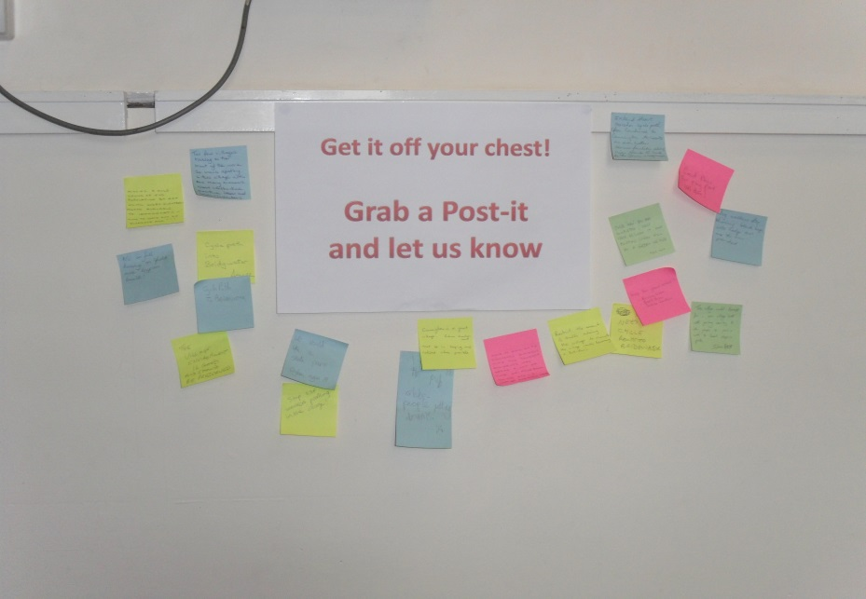**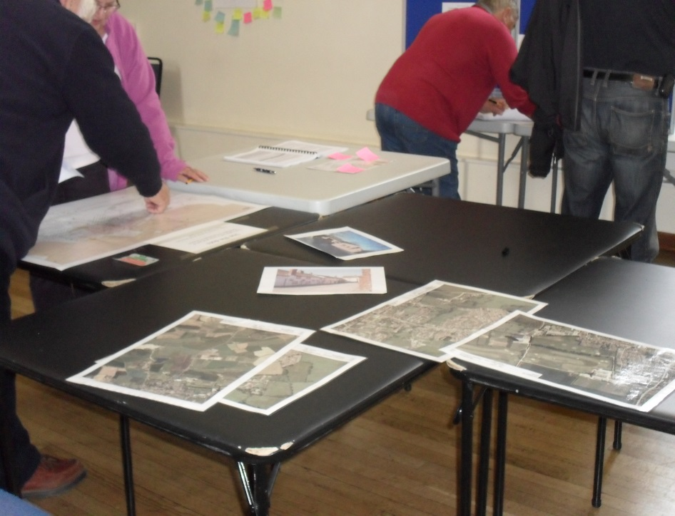CONSULTATION STATEMENT**

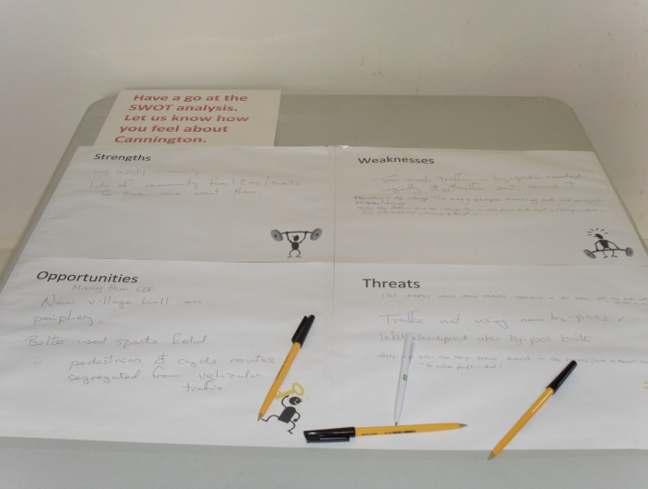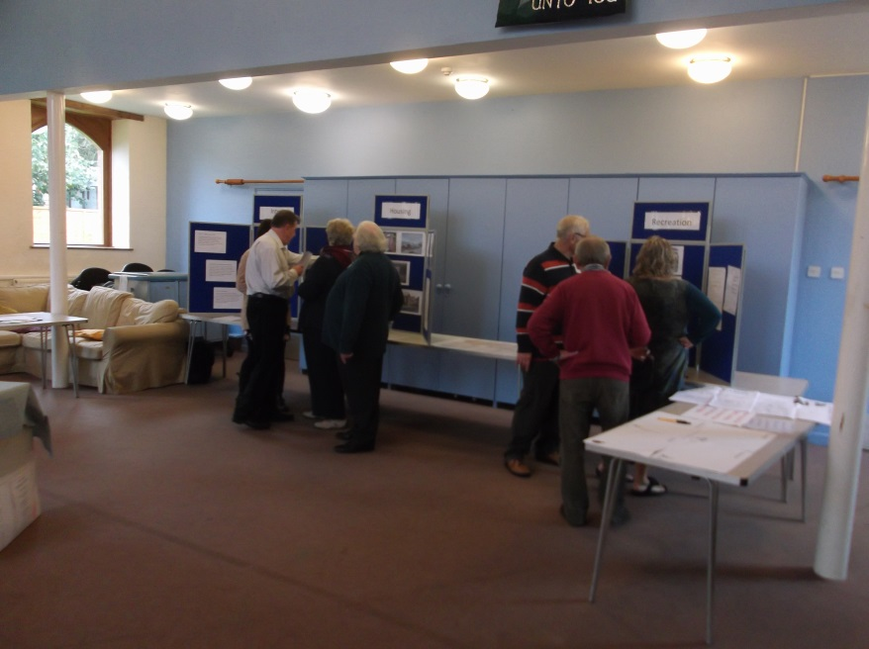

**Prepared by:** Cannington Neighbourhood Plan Steering Group  
  
**Produced on behalf of Cannington Parish Council by the Cannington Neighbourhood Plan Steering Group**

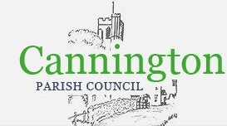

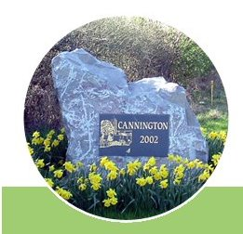

CONTENTS: Page No:

Introduction 3

Neighbourhood Area 4

Neighbourhood Plan Initial Questionnaire 5

1st Public Open Meeting 6

Website 6

2nd Public Open Meeting 7

3rd Public Open Meeting 8

4th Public Open Meeting 9

5th Public Open Meeting 10

Surveys/Questionnaire’s 11

Youth Survey 11

Business Survey 12

Last Chance Questionnaire 13

How the Issues, Priorities and Concerns have been considered 15

|  |  |  |
| --- | --- | --- |
| Tables | Title | Page No: |
| 1 | Programme of consultation | 3 |
| 2 | Overview of initial questionnaire | 5 |
| 3 | Overview of 1st public meeting | 6 |
| 4 | Overview of 2nd public meeting | 7 |
| 5 | Overview of 3rd public meeting | 8 |
| 6 | Overview of 4th public meeting | 9 |
| 7 | Overview of 5th public meeting | 10 |
| 8 | Overview of Youth Survey | 11 |
| 9 | Overview of Business Survey | 12 |
| 10 | Last Chance Questionnaire | 13 |
| 11 | Policies and Issues, Priorities and Concerns Raised | 15 |

|  |  |
| --- | --- |
| Appendix | Title |
| 1 | Initial questionnaire |
| 2 | Initial questionnaire results (have paper copies only) |
| 3 | Summary of survey results – Initial survey |
| 4 | SWOT results |
| 5 | Leaflet advertising public events in October |
| 6 | Kitchener poster |
| 7 | Leaflet posted in all letter boxes |
| 8 | Youth questionnaire |
| 9 | Survey results – Youth |
| 10 | Business questionnaire |
| 11 | Survey results – Business |
| 12 | Community questionnaire |
| 13 | Survey results – Community |

#### Introduction

This Consultation Statement has been prepared to fulfil the legal requirements of Part 5, Section 15 of the Neighbourhood Planning (General) Regulations 2012 by:

Detailing the persons and bodies who were consulted about the proposed neighbourhood development plan;

Outlining how these persons and bodies were consulted;

* Providing a summary of the main issues and concerns raised;
* Reviewing how these issues and concerns have been considered and, where relevant, addressed in the proposed neighbourhood development plan.

The Programme of consultation completed is detailed in table 1.

**Table 1 – Programme of consultation**

|  |  |
| --- | --- |
| November 2013 | Initial Questionnaire posted to every letter box. |
| 21st January 2014 | Public Open Meeting in Village Hall |
| 18th October 2014 | Public Open Meeting in Village Hall |
| 22nd October 2014 | Public Open Meeting in Primary School |
| 29th October 2014 | Public Open meeting in United Reform Church |
| 29th November 2014 | Public Open meeting in Village Hall |
| January 2015 | Electronic Survey - Youth |
| January 2015 | Electronic and Paper Survey – Business |
| January 2015 | Electronic and Paper Survey - Community |

This Consultation Statement provides an overview of each of the above stages of consultation in accordance with Section 15 (2) of Part 5 of the neighbourhood Planning (General) Regulations.

#### Neighbourhood Area

The whole parish of Cannington has been formally designated as a Neighbourhood Area through an application made by Sedgemoor District Council on 10th July September 2013 under Part 2, Section 5 of the Neighbourhood Planning (General) Regulations 2012.

The Neighbourhood Plan area was officially approved by Sedgemoor District Council on 24th September 2013, following a 6 week period of public consultation as required within part 2, Section 6 of the Neighbourhood Planning (General) Regulations 2012.

The designated ‘Cannington Neighbourhood Area is illustrated in figure 1 (below.

Figure 1: Map of Cannington Neighbourhood Area



**Crown Copyright. All rights reserved. Sedgemoor District Council. 100024272**

#### Neighbourhood Plan Initial Questionnaire

An overview is provided in table 2

**Table 2 - Overview of initial questionnaire**

|  |  |
| --- | --- |
| Date | November 2013 |
| Target | The whole community |
| Facilitator | Cannington Parish Council |
| Format | Questionnaire |
| Publicity | Leaflet dropped to all households & businesses in Cannington |
| Copy of leaflet | Initial Questionnaire |
| Responses | 90 |
| Data | Results – paper copies (summary in Appendix 3) |

This was the first public consultation undertaken by Cannington Parish Council which aimed to inform the community about Neighbourhood Planning, the questionnaire asked people what they liked/disliked about the village, what they want to preserve and change.

Who was consulted?

The questionnaire was posted to all households, and was publicised in the parish quarterly magazine called ‘The Cannington Target’.

A total of 90 questionnaires (Appendix 1 – Initial Questionnaire Template) were returned. The completed forms can be viewed at The Parish Office in the village hall.

All issues, priorities, concerns and comments received were collated and presented in the form of a summary (see Appendix 3) and informed the content of material provided for future consultation.

#### 1st Public Open Meeting

An overview of the event is provided in table 3

**Table 3 - Overview of 1st public meeting**

|  |  |
| --- | --- |
| Date | 21st January 2014 |
| Venue | Cannington Village Hall |
| Facilitator | Cannington Parish Council |
| Format | Public Open Meeting |
| Publicity | Parish magazine and notice board. |
| Attendance | 30 |

This was the first of five public meetings, it was held by the Parish Council.

The aim of this initial public event was to engage and consult with as many members of the local community as possible to ascertain the demand to produce a neighbourhood plan and if there was enough interest and volunteers to form a steering group.

30 people attended the meeting and it was decided to continue with the plan. 8 volunteers agreed to form a steering group; subsequent to the meeting another member came forward. Cannington Neighbourhood Plan Steering Group was formed.

Who was consulted?

The open meeting was publicised in the parish quarterly magazine called ‘The Cannington Target’ which is posted to every household in the parish. The meeting was also advertised on the Parish Notice Board.

A total of 30 people attended the meeting.

#### Website

Cannington Neighbourhood Plan website became live on 24th November 2014, the web address is <http://cannington-neighbourhoodplan.info/>. The website is a forum to advertise Cannington Neighbourhood Plan events, give feedback, to provide an update on the progress of the plan and give general information on neighbourhood planning.

The Steering Group publicises its meetings (which are open to the public), agenda’s and minutes are also available on the website.

#### 2nd Public Open Meeting

An overview of the event is provided in table 4

**Table 4 - Overview of 2nd public meeting**

|  |  |
| --- | --- |
| Date | 18 October 2014 - 10am til 4pm |
| Venue | Cannington Village Hall |
| Facilitator | CNP Steering Group |
| Format | Public Open meeting  Public information board  Forms available for completion  SWOT analysis  Map to allow people to pinpoint where they would like to see future development |
| Publicity | Invitations sent to every household & business in Cannington early October 2014  Posters, Facebook |
| Attendance | 70 |
| Data | Initial Survey and SWOT |

This was the first public meeting held by Cannington Neighbourhood Plan Steering Group. The aim of this meeting was to engage and consult with as many members of the local community as possible. A Strengths, Weakness, Opportunities and Threats (SWOT) analysis was undertaken and comments provided on various issues were collated, results can be found at Appendix 4 – SWOT Results. A further opportunity to complete the Initial Questionnaire was also offered, results can be found at Appendices 2 and 3.

Who was consulted?

The meeting was publicised on the website and on a social network, in the parish quarterly magazine called ‘The Cannington Target’, on the Parish Council Notice Board. A leaflet inviting people to this meeting and another meeting held on the 29th October was posted to every household and business in Cannington (See Appendix 4, leaflet advertising both meetings 18 and 29 October).

A total of 70 people attended the meeting.

#### 3rd Public Open Meeting

An overview of the event is provided in table 5

**Table 5 - Overview of 3rd public meeting**

|  |  |
| --- | --- |
| Date | 22 October 2014 – 2pm til 4pm |
| Venue | Cannington Church of England Primary School |
| Facilitator | CNP Steering Group |
| Format | Open meeting  Public information board  Forms available for completion  SWOT analysis  Map to allow people to pinpoint where they would like to see future development |
| Publicity | Invites were given to every child  Posters, Facebook |
| Attendance | 1 |
| Data | Initial Survey and SWOT |

This public meeting was held in the local primary school to try and engage young families in Cannington.

A Strengths, Weakness, Opportunities and Threats (SWOT) analysis was undertaken and comments provided on various issues were collated, results can be found at Appendix 4 – SWOT Results. A further opportunity to complete the Initial Questionnaire was also offered, results can be found at Appendix 2 and 3.

Who was consulted

An invite was given to each child in Cannington Church of England Primary School.

Unfortunately only one person attended this meeting.

#### 4th Public Open Meeting

An overview of the event is provided in table 6

**Table 6 - Overview of 4th public meeting**

|  |  |
| --- | --- |
| Date | 29 October 2014 – 2pm til 4pm |
| Venue | United Reformed Church |
| Facilitator | CNP Steering Group |
| Format | Open meeting  Public information board  Forms available for completion  SWOT analysis  Map to allow people to pinpoint where they would like to see future development |
| Publicity | Invitations sent to every household & business in Cannington early October 2014  Flyers, Posters, Facebook |
| Attendance | 17 |
| Data | Initial Survey & SWOT |

This was the fourth public meeting and held by Cannington Neighbourhood Plan Steering Group. The aim of this meeting was to engage and consult with as many members of the local community as possible by changing the location. A Strengths, Weakness, Opportunities and Threats (SWOT) analysis was undertaken and comments provided on various issues were collated, results can be found at Appendix 4 – SWOT Results. A further opportunity to complete the Initial Questionnaire was also offered, results can be found at Appendix 2 and 3.

Who was consulted?

The meeting was publicised on the website and on a social network, in the parish quarterly magazine called ‘The Cannington Target’, on the Parish Council Notice Board. A leaflet inviting people to this meeting and another meeting held on the 22nd October was posted to every household and business in Cannington (See Appendix 5, leaflet advertising both meetings 18 and 29 October).

A total of 17 people attended the meeting.

#### 5th Public Open Meeting

An overview of the event is provided in table 7

**Table 7 - Overview of 5th public meeting**

|  |  |
| --- | --- |
| Date | 29 November 2014 – 10am til 4pm |
| Venue | Cannington Village Hall |
| Facilitator | CNP Steering Group |
| Format | Display boards with Fact Sheets  Forms available for completion  SWOT analysis  Map to allow people to pinpoint where they would like to see future development |
| Publicity | Flyers, Posters, Parish Website, Facebook |
| Attendance | 39 |
| Data | Initial Survey & SWOT |

The aim of this public meeting was to share feedback received thus far and engage on the issues raised. It was also hoped that any persons who had not yet make any comments would be able to or further comments could be made. A Strengths, Weakness, Opportunities and Threats (SWOT) analysis was undertaken and comments provided on various issues were collated, results can be found at Appendix 4 – SWOT Results. A further opportunity to complete the Initial Questionnaire was also offered, results can be found at Appendix 2 and 3.

Who was consulted

The public meeting was publicised on the website, on a social network and in the parish quarterly magazine called ‘The Cannington Target’. Adverts were placed around the village (see Appendix 6 – Kitchener poster and Appendix 7 - leaflet posted in every letter box).

A total of 39 people attended the meeting.

#### Surveys/Questionnaire’s

Surveys were distributed and targeted at specific demographics, to give the opportunity, for all members of the community to express their views, on what is important to them in the village and how they would like Cannington to develop in the future.

Three separate surveys were produced; one aimed at the youth, another towards businesses and the third to the general community called the ‘Last Chance Questionnaire’.

#### Youth Survey

An overview is provided in table 8

**Table 8 - Overview of Youth Survey**

|  |  |
| --- | --- |
| Date | January 2015 |
| Target | Youth |
| Facilitator | CNP Steering Group |
| Format | Electronic Survey |
| Publicity | A link to the survey was advertised on Cannington Neighbourhood Plan and Cannington Parish Council’s websites as well as being shared on Social Media and advertised in The Cannington Target. |
| Attendance | 13 completed surveys were received |
| Data | Youth Survey Results |

The aim of this questionnaire was to engage and consult with the younger generation of the village, aimed specifically at the youth to engage with as many members of the local community as possible.

Who was consulted

The survey was produced electronically publicised on Cannington Neighbourhood Plan and Cannington Parish Council’s website, via social media and in the parish magazine, The Cannington Target. A prize draw was advertised, selecting 3 completed questionnaires to encourage participation; the prizes consisted of 3 x £10 Book Vouchers.

A total of 13 surveys (Appendix 8 – Youth Survey) were completed and the feedback from these can be found in Appendix 9 – Youth Survey Results.

#### Business Survey

An overview is provided in table 9

**Table 9 - Overview of Business Survey**

|  |  |
| --- | --- |
| Date | January 2015 |
| Target | Businesses |
| Facilitator | CNP Steering Group |
| Format | Paper and Electronic Survey |
| Publicity | 83 targeted letters were sent to businesses and the survey was advertised on Cannington Neighbourhood Plan and Cannington Parish Council’s website. |
| Response | 13 completed surveys were received |
| Data | Business Survey |

The aim of the business survey was to engage and consult with the business community.

Who was consulted?

The survey was produced in electronic and paper, posted to 83 businesses in the parish. It was publicised on Cannington Neighbourhood Plan and Cannington Parish Council’s website. A total of 13 surveys (Appendix 10 – Questionnaire Template) were completed and returned and the feedback from these can be found in Appendix 11 – Business Survey Results.

#### Last Chance Questionnaire

An overview is provided in table 10

**Table 10 – Last Chance Questionnaire**

|  |  |
| --- | --- |
| Date | January 2015 |
| Target | The whole community |
| Facilitator | CNP Steering Group |
| Format | Electronic and Paper Survey |
| Publicity | The questionnaire was posted to all households and business in Cannington. A link to the survey was advertised on Cannington Neighbourhood Plan and Cannington Parish Council’s websites as well as being shared on Social Media and advertised in The Cannington Target. |
| Response | A total of 104 surveys were completed over the whole consultation period |
| Data | Community Questionnaire Results |

The aim of this questionnaire was to engage and consult with as many members of the local community as possible. This was the last opportunity for the community to provide their comments.

Who was consulted?

The questionnaire was produced electronically as well as on paper. These were posted to all households and businesses, and was publicised in the parish quarterly magazine called ‘The Cannington Target’, on the Cannington Neighbourhood Plan and Cannington Parish Council’s website and on social media.

A total of 104 questionnaires (Appendix 12 – Community Questionnaire Template) were completed and returned and the feedback from these can be found in Appendix 13 – Community Questionnaire Results.

Issues, Priorities and Concerns Raised

The following key themes arose from the consultation process:

**Traffic & Transport:**

* Speed of traffic in and around Cannington.
* Traffic calming required.
* Limited provision of car parking in the village centre.
* Lack of public transport available.
* Potential adverse impacts of future development on volume and movement of traffic.
* All new development must have adequate parking.
* Traffic restrictions should be applied.

**Housing:**

* Concern that new developments will be granted permission before adoption of the neighbourhood plan.
* Additional housing development will put pressure on already stretched amenities and infrastructure.
* Housing should meet the needs of the local population (including the elderly).
* No mass housing developments, small developments preferred.
* Affordable housing should be a priority.
* Mixed style of housing.
* Keep as a village, not joining to neighbouring settlements.
* Development to be attached to the village boundary

**Business:**

* Relatively happy with the variety of retail offer and would wish to maintain this.
* New business welcome.
* Utilisation of existing business space.

**Community / Leisure Facilities:**

* Need a full sports complex.
* Footpath improvements.
* Services for the elderly.
* Community participation.
* Village Hall lacks facilities such as access and parking.

**Healthcare:**

* Priority to improve / expand healthcare services (Doctors, Dentists & Chemists).

**Environment:**

* A green wedge should be protected.
* Priority to mitigate against flooding within and around any new development.
* Need to maintain and enhance access to open space and countryside.
* Green corridors needed or enhanced.
* Tree planting.
* Sustainable development.
* Dog bins.

#### How the Issues, Priorities and Concerns have been considered

All issues, priorities, concerns and comments put forward were collated and used to:

1. Inform the development of the overall vision and objectives of the plan.
2. Set key issues and priorities for further exploration.
3. Guide the structure, format, and content of subsequent consultation and engagement.
4. Formulate policies in the neighbourhood plan (Table 11 below)

**Table 11 – Policies and Issues, Priorities and Concerns Raised**

|  |  |  |
| --- | --- | --- |
| Policy | | Issues, Priorities and Concerns Raised |
| HOUS1 | *Support will be given to development proposals which are located within or directly adjacent to the existing development boundary.*  *There is an expectation that development proposals within the village will be of a small scale (less than 20 houses) and where it can be demonstrated that development will contribute to the wider sustainability benefits of the village.*  *Development should be avoided on land as identified by Policy ENV 7 as these locations have been identified as particularly sensitive locations for development.*  *Development proposals will only be permitted where they are:*   * *Well related to existing essential services and social facilities within the settlement; and* * *There is safe and easy pedestrian access to the essential services and social facilities within the settlement; and* * *It respects the historic environment and complements the character of the existing settlement; and* * *It does not generate significant additional traffic movements over minor roads and to and from the national primary and county highway routes; and*   *It does not harm the amenity of the area or adjoining land uses.* | * Development to be attached to the village boundary * No mass housing developments, small developments preferred. * Additional housing development will put pressure on already stretched amenities and infrastructure. * Priority to improve / expand healthcare services (Doctors, Dentists & Chemists). * Footpath improvements. * Speed of traffic in and around Cannington. * Traffic calming required. * Limited provision of car parking in the village centre. * Potential adverse impacts of future development on volume and movement of traffic. * All new development must have adequate parking. * Sustainable development. |
| ENV01 | *The areas shown on figure 7 above are of important value to the local character and setting of the village of Cannington or they are important community assets/sports pitches which are well used. They as open spaces provided an important break within the context of the built form of the village and are highly sensitive to landscape change.*  *Accordingly, development proposals which see the loss of these to the local community or community based teams should be avoided.*  *Where the loss of sports pitches does occur the expectation that facilities of better standard within accessible locations to the village should be provided in advance of loss of existing spaces.* | * Need a full sports complex. * Footpath improvements. * A green wedge should be protected. * Need to maintain and enhance access to open space and countryside. * Green corridors needed or enhanced. * Sustainable development. |
| TRANS01 | *All new residential development in Cannington will ensure that: -*   * *Development is planned and designed to minimize additional traffic through the village centre* * *Development will not be allowed where the visibility splays associated with new access arrangements fall below modern highway safety requirements.* * *Where appropriate adequate bus stops and shelters are provided at convenient locations* * *Safe routes for walking and cycling are provided which conveniently connect with existing networks* * *Sufficient car parking is to be provided with a preference for car parking spaces to be provided off-street and within dedicated garages*   *On-site transport infrastructure is provided and brought into use before first occupation of part of the development which is to be served by that element of infrastructure. Any necessary off-site infrastructure shall be provided and brought into use in accordance with a timescale to be agreed by the local planning authority and secured by a planning condition or planning obligation as appropriate.* | * Speed of traffic in and around Cannington. * Traffic calming required. * Limited provision of car parking in the village centre. * Lack of public transport available. * Potential adverse impacts of future development on volume and movement of traffic. * All new development must have adequate parking. * Traffic restrictions should be applied. * Footpath improvements. * Sustainable development. |
| TRANS02 | *All new commercial development in Cannington will ensure that:*   * *Development is planned and designed to minimize additional pressure for car parking spaces within the village centre and in and around existing commercial facilities* * *Where possible all endeavours will be made by applicants to seek to help resolve and alleviate existing parking restrictions.* * *Safe routes for walking and cycling are provided which conveniently connect with existing networks.*   *On-site transport infrastructure is provided and brought into use before first occupation of part of the development which is to be served by that element of infrastructure. Any necessary off-site infrastructure shall be provided and brought into use in accordance with a timescale to be agreed by the local planning authority and secured by a planning condition or planning obligation as appropriate.* | * Speed of traffic in and around Cannington. * Traffic calming required. * Limited provision of car parking in the village centre. * Potential adverse impacts of future development on volume and movement of traffic. * All new development must have adequate parking. * Traffic restrictions should be applied. * Sustainable development. |
| TRANS03 | *New residential or employment development and associated infrastructure will: -*  *Provide appropriate public foot and cycle paths to connect with the existing foot and cycle path network.* | * Footpath improvements. * Sustainable development. |
| ECON01 | *Support will be given for the conversion of existing properties (other than existing public houses, valued community services such as doctor’s surgery, school, and community facilities) to commercial use classes A1 to A5 and to light industrial use classes B1 provided that the amenities of neighbouring residential properties can be preserved. Amenity considerations shall include the following:*   * *Hours of operation* * *Noise considerations* * *Refuse storage, fume extraction and potential odours* * *Outdoor seating area* * *Parking and delivery arrangements*   *Proposals which propose new commercial uses should seek to ensure that all parking provision is made off-street and within defined and dedicated spaces.* | * Relatively happy with the variety of retail offer and would wish to maintain this. * New business welcome. * Utilisation of existing business space. * Limited provision of car parking in the village centre. * All new development must have adequate parking. * Sustainable development. |
| EDU01 | *Support will be generally given to the further expansion of existing education facilities both in terms of their education offer and range of facilities provided that such expansion and growth does not result in an adverse impact on the wider functioning of the village.*  *There is an expectation that education proposals will seek, where possible, to provide more than the minimum level of parking provision so as to minimise and help reduce existing restraints associated with parking in the village.  Education proposals should also consider opportunities to improve upon community access.* | * Additional housing development will put pressure on already stretched amenities and infrastructure. * Need a full sports complex. * Footpath improvements. * Community participation. * Sustainable development. |